**Learner Guide – Azure App Dev**

1. Download source code from - <https://git.io/vFQUN>

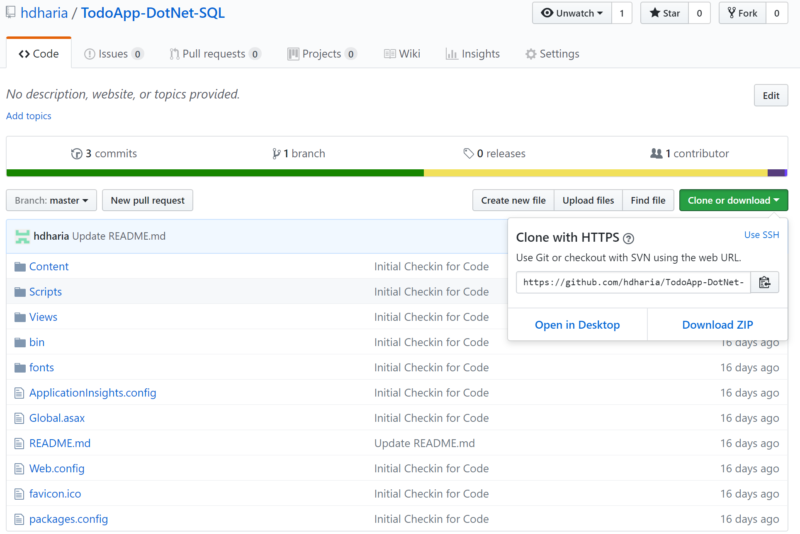

1. Create Azure SQL PaaS database Instance (S0 Tier)
   1. Create a New Resource 🡪 SQL Database 🡪 Create
   2. Use the following to create a new database instance and database server

Database Name: mytododb_<initial>

Resource Group: mytododb_<initial>

Select Source: Blank Database

Server 🡪 Create New

Server Name: mytododbserver<initial>

Server Admin Login: <user_id>

Location: East US

Pricing Tier: S0, Storage 1GB

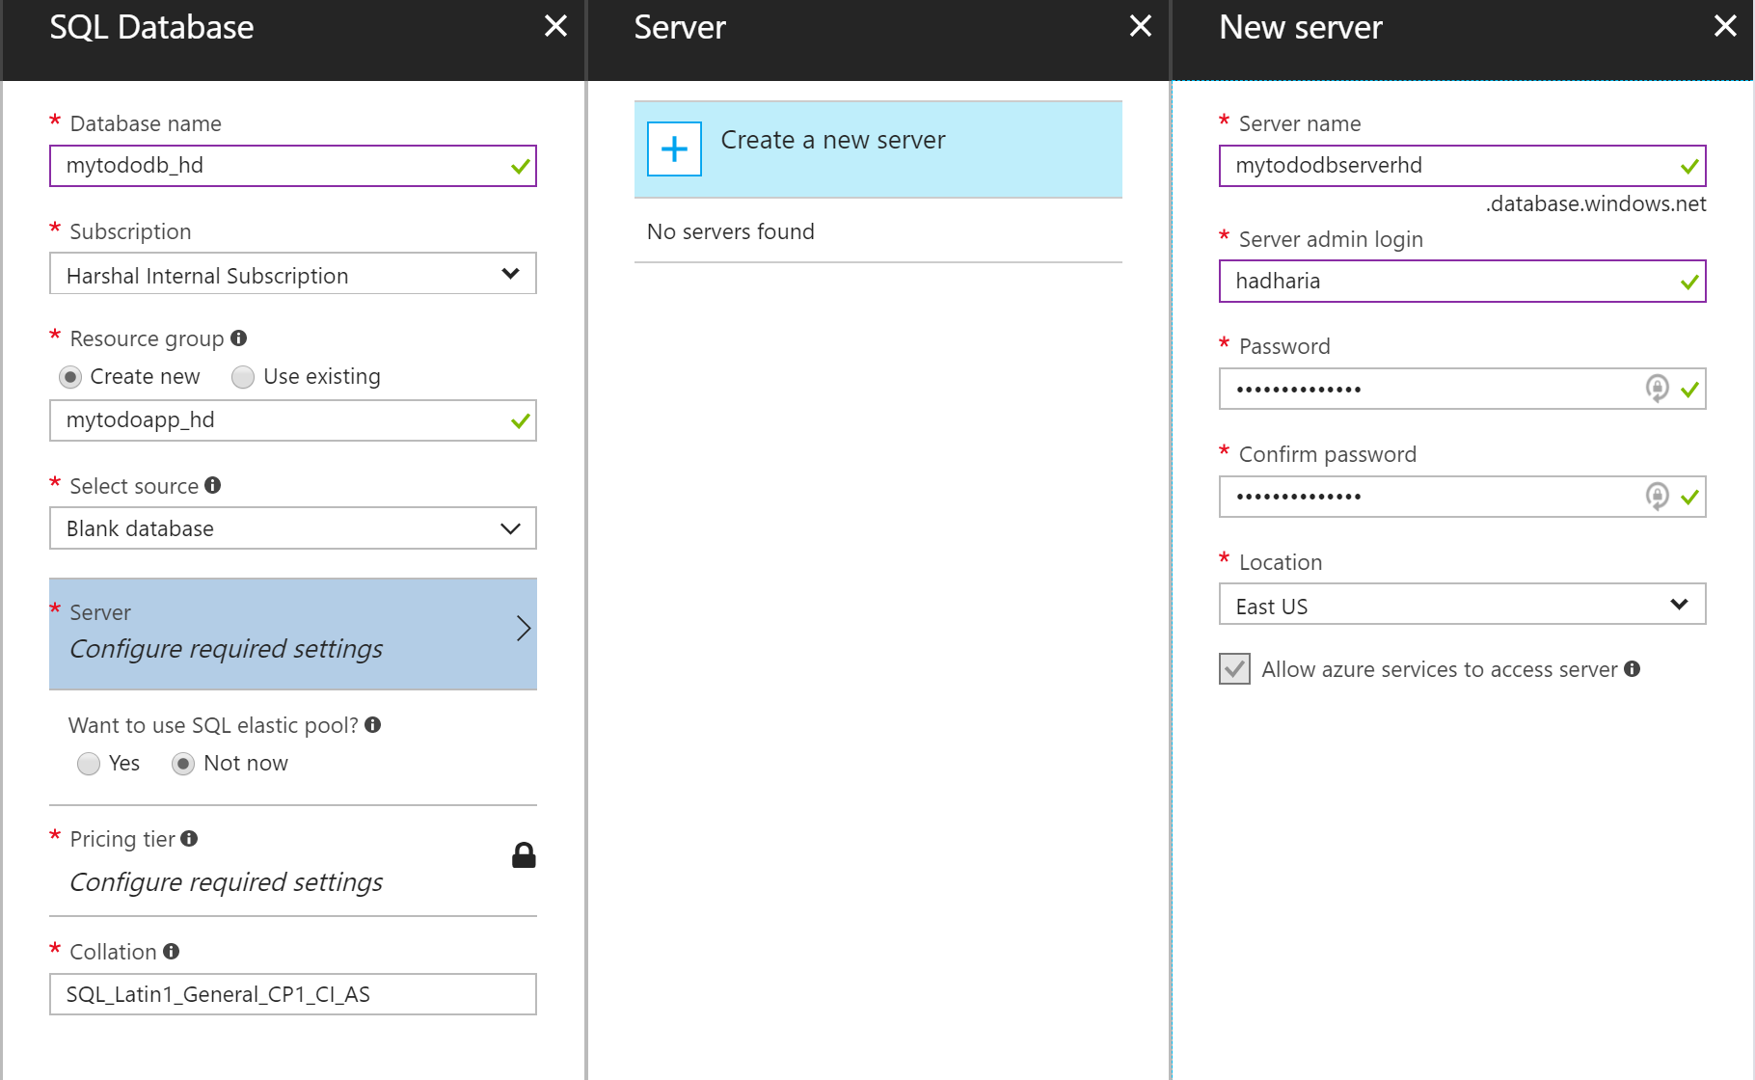

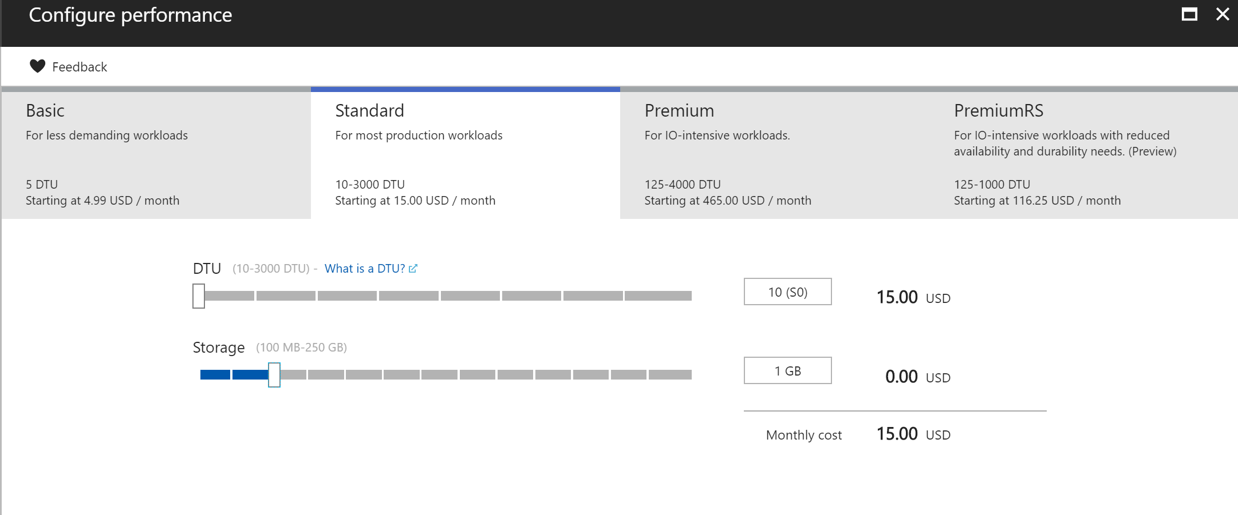

1. Create Azure Webapp & App Service Plan (S1 Tier)
   1. Create a new resource 🡪 Webapp 🡪 Create

App Name: mytodoapp<initial>

Resource Group: mytodoapp_<initial> (Created previously)

OS: Windows

App Service Plan 🡪 Create New

App Service Plan: mytodoapp-sp-<initial>

Location: East US

Pricing Tier: S1 Standard

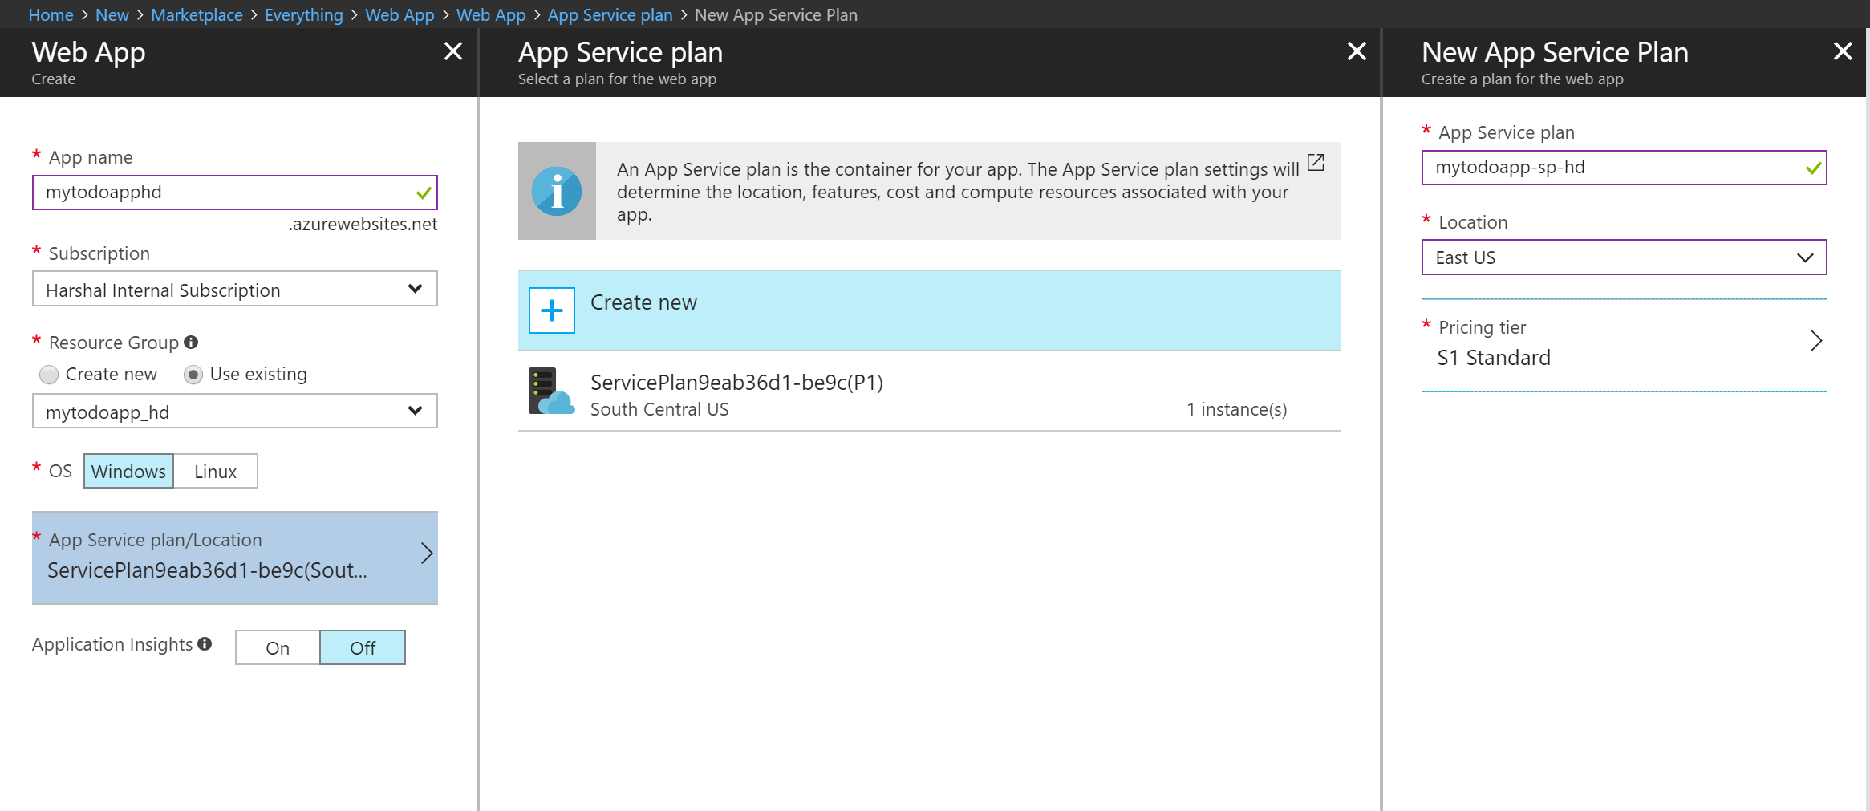

1. Update the application setting with connection string information – “MyDbConnection”
   1. Retrieve Connection String from Resource Groups 🡪 mytododb_<initial> 🡪 connection strings
   2. Update the connection string with user id and password used to create the database server
   3. Set the connection in application settings from Resource Groups 🡪 mytodoapp_<initial> 🡪 mytodoapp<initial> (Webapp/App Service) 🡪 application settings
   4. Add “MyDbConnection” under connection string

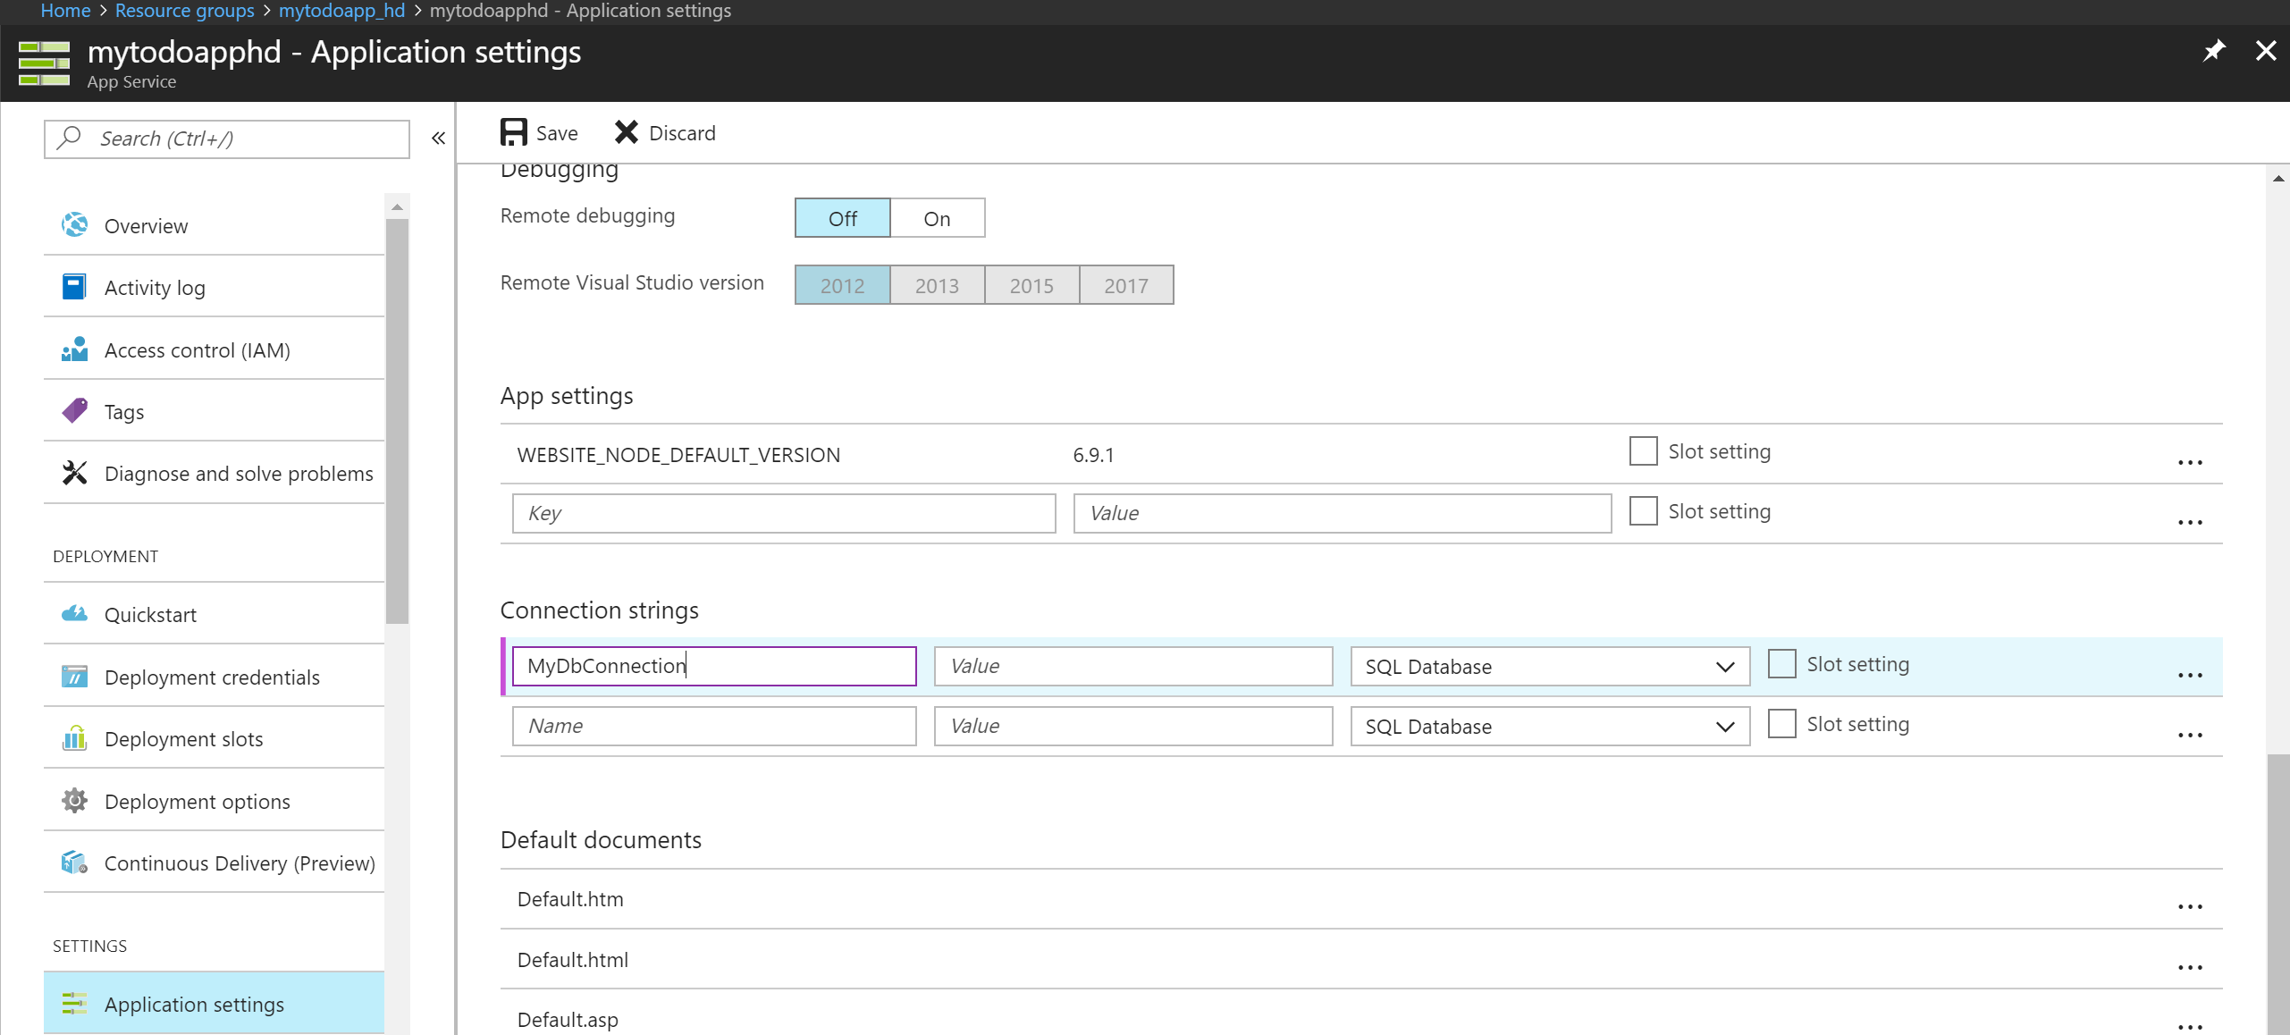

* 1. Save

1. Deploy code via FTP or Kudu Console using publish profile credentials.
   1. Get Publish profile credentials
   2. Login into the ftp endpoint as per the link on Overview blade
   3. Upload source code into site/wwwroot folder.

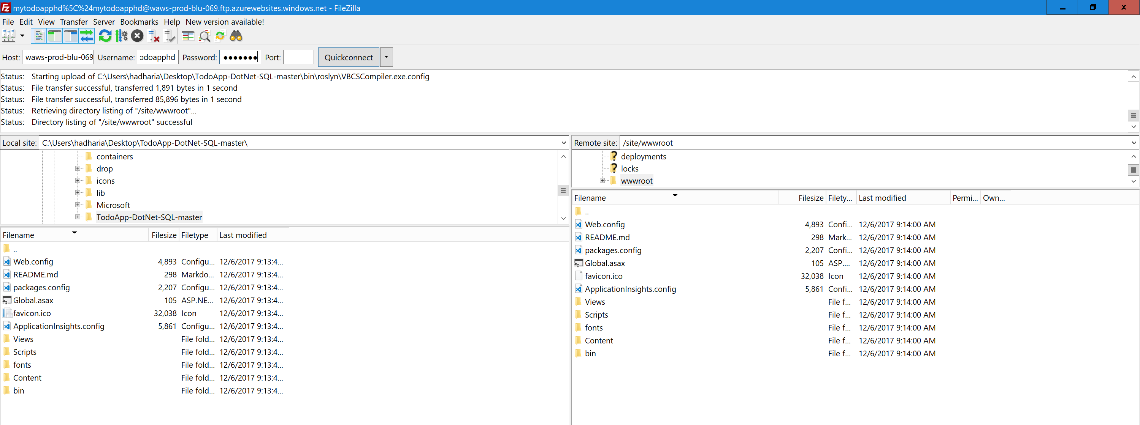

1. Navigate to the main URL under overview blade to see functioning todo app.

